**GUIDANCE ON HOW TO GENERATE USE CASES/ USER STORIES, AND VARIABLES FROM AVAILABLE DATASETS**

The following provides simple steps to generate use cases and user stories from available datasets with the aim to conduct an exploratory data analysis.

**Use Case**

A use case must have a product it promotes, actors in terms of interaction such as a user, a scenario, pointing to a user and the system or process, and then the experience which is the goal can be a benefit or success from the scenario therefore well-defined details of what is required. For example, think of a use case about**a bicycle rider (cyclist) who wants to know where he can park his bicycle safely as he visits the city for Melbourne events such as Melbourne open, (an event in Melbourne) noting that safety is his main goal.**  According to transport strategy 2030, the city proposes bicycles to become everyday transport by 2030, and one of the many current challenges to achieving this strategy is not having access to convenient bicycle parking.

Having successfully arrived at a use case that aligns with the goal/strategy of the city, you need to look at the data available and from there, develop user stories. However, even if data are not available, you might propose.

In a simple form, as above, the use case is on Bicycle Parking (Note that this use case already exists).

**User Stories**

User Stories explains more with a focus on the goal, written from the perspective of the user which in the example above is a cyclist, although not explicit, it dictates the acceptance criteria and user role.

A user story usually starts with “As a user…...<pedestrian, cyclist, or council…...type of user>, I/we want to ……<the main intention or objective>…. to <the reason>.

Following the pattern above gives a better clue and direction for your work.

# **An EDA defined**

*A process relating to investigating data in a bid to discover the design, identify mistakes, hypothesis testing, examine assumptions, using statistics (measures of central tendency and measures of dispersion), and graphical representation. EDA gives clarity on how one explanatory variable ranks in significance over others and assesses relationships between independent and dependent variables.*

*Note: It is important to use EDA with graphical technique as this is its main role and analyst can easily get insights into the data.*

Just as before any organization commences business, the goal must be reviewed.

Make research on strategic goals the city is currently investing in or is of interest now.

Resources for research are:

Domain 1: Safety and well-being.

Step 1: Search out “what is the city of Melbourne’s goals on Safety and well-being”

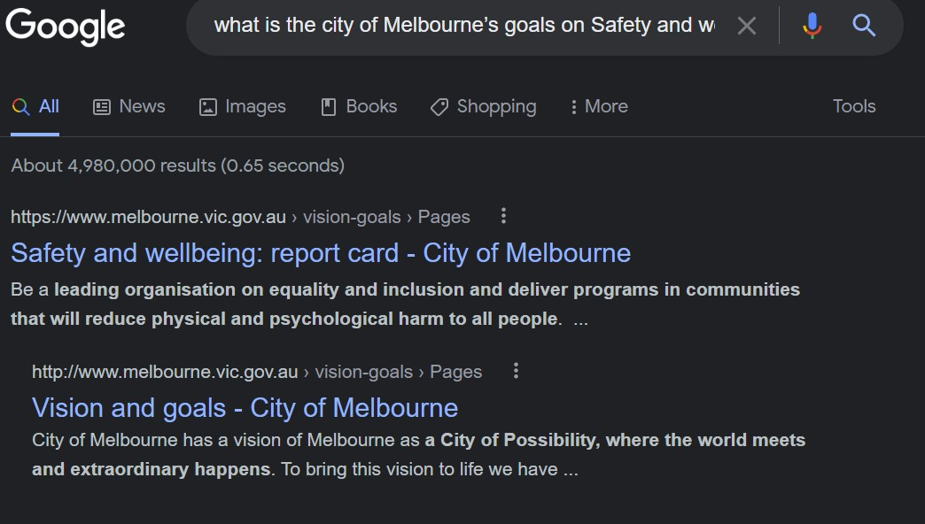

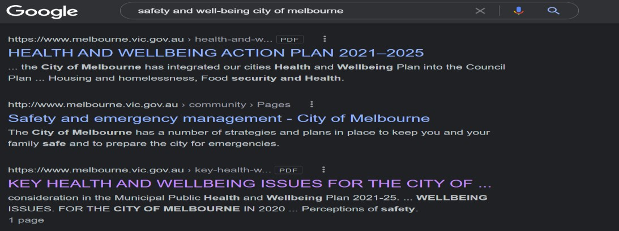

From the above, you can click and read the contents of the link, make further research, and compare which aspect has been addressed and those promising ones.

Step 2: Go to the open dataset and review the columns and rows, to determine if the dataset would suffice for your proposed use case.

Consider additional data sources and if the state of the data is current, or obsolete.

Step 3: Understand the data and what insight is derivable.

• What kind of data are you working with? Categorical, continuous, or discrete 1. -Categorical (nominal or ordinal), and

- Continuous (interval or ratio).

• Determine your variables

To test for relationships, a dependent variable (also outcome or response variable) will be your result of the experiment where the independent variable (explanatory variable) has been manipulated. In other words, when the x-axis represents the explanatory, then the y-axis is the dependent variable.

The independent predict what the outcome will be.

**Give it an observation**

The purpose of the plots or visualization is to give an observation or insight into the data.

It is better to state your points as insights or observations.

A better understanding of the above clarifies how to write a use case and gives clarity to your work.

Keep it simple but impactful.

References

Visual-paradigm.com. 2022. *User Story vs Use Case for Agile Software Development*. [online] Available at: <https://www.visualparadigm.com/guide/agile-software-development/user-story-vs-use-case/> [Accessed 29 September 2022].

Patil, P., 2018. *What is Exploratory Data Analysis?*. [online] Medium. Available at: <https://towardsdatascience.com/exploratory-dataanalysis-8fc1cb20fd15> [Accessed 29 September 2022].

Library, C., 2022. *Data & variable types - Introduction to statistics - UniSkills - Curtin Library*. [online] Uniskills.library.curtin.edu.au. Available at: <https://uniskills.library.curtin.edu.au/numeracy/statistics/data-variable-types/> [Accessed 29 September 2022].

Terski, M., 2022. *Use Cases in an Agile Backlog*. [online] Blog.casecomplete.com. Available at:

<https://blog.casecomplete.com/post/Use-Cases-in-an-Agile-Backlog> [Accessed 29 September 2022].